Milestone 3 – White Paper, Questions, and Code
Maria Toledo
DSC 680
Business Problem
Quality Control and Defect Management play a critical role in Manufacturing, as defects that occur during production or assembly can lead to increased repair costs, production delays, and reduced customer satisfaction. A manufacturing defect is a flaw that occurs during the production or assembly of a product (Cayabyab, 2025). When these defects go undetected, the consequences can be costly. For reference, businesses in the United States faced fines totaling $55.3 million in 2023 from manufacturing defects (Cayabyab, 2025). Effective defect management is therefore essential for minimizing both operational and financial risks.
Background/History
Quality Control refers to the process of identifying potential defects before products reach customers (Quality Gurus, 2025). There are different methods for identifying defects. The dataset categorizes inspections into three types: visual, manual, and automated. A robust quality control process enables organizations to avoid costly defects and maintain their safety standards. Defects are categorized into three severity levels: minor, moderate, and critical. Critical defects are the most severe and can result in physical harm to workers or customers; they also require the most expensive corrective actions. Critical defects have a 0% tolerance level (HQTS, 2024).
Data Explanation
The dataset for this project was sourced from Kaggle and contains simulated records of defects identified during quality control processes. Data preparation included one-hot encoding for categorical variables and label encoding for severity levels. The dataset includes several key fields, including defect ID, product ID, defect type, defect description, date of detection, defect location, severity, inspection method, repair action, and repair cost. These variables collectively provide a comprehensive view of the types of defects observed, how they were detected, and the associated repair costs.
Link: Manufacturing Defects

Methods
Descriptive analytics
The descriptive analysis began by examining defect frequency by type. The bar chart revealed a relatively balanced distribution across cosmetic, functional, and structural defects. A similar pattern emerged when analyzing defect frequency by location: surface, component, and internal defects occurred at comparable rates. When examining defects over time, January had the highest number, while June had the lowest.

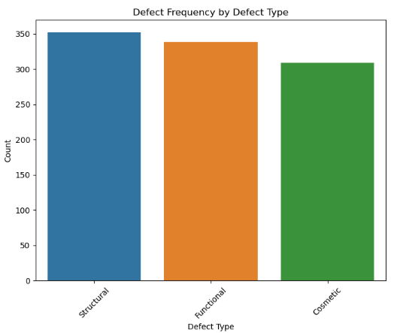
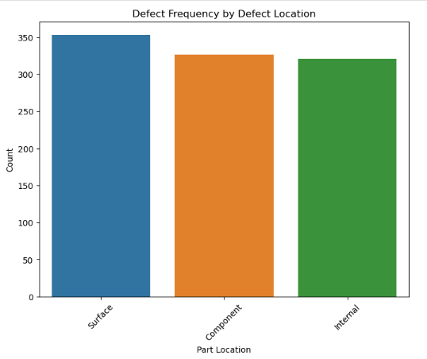
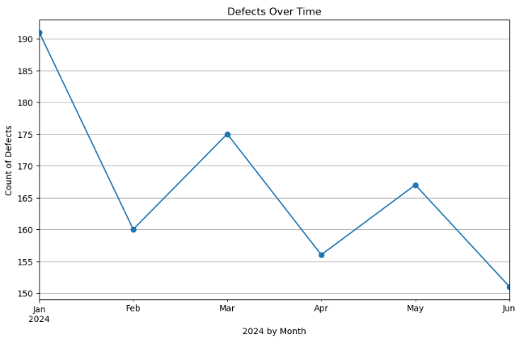

Repair costs were analyzed using a boxplot, which showed that costs were similar across defect types, although cosmetic defects were slightly more expensive on average. A heatmap illustrating severity levels by inspection method revealed that manual testing detected the majority of minor defects, suggesting that manual inspections are effective at identifying small issues. In contrast, automated testing detected only a few moderate defects, suggesting it may be less effective at identifying issues of intermediate severity.

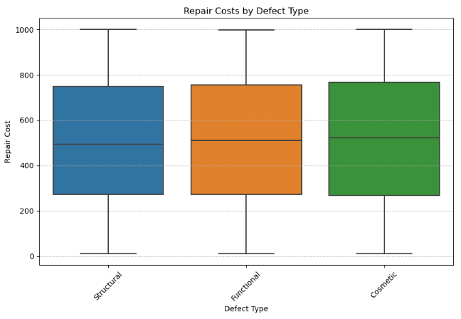
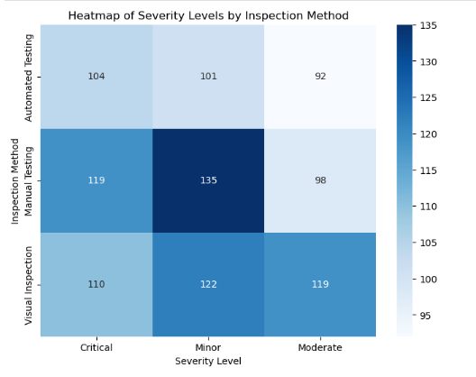

Predictive analytics
Two predictive models were developed to analyze defect severity and repair costs. A linear regression model was used to predict repair costs, yielding a root mean squared error (RMSE) of 294. This level of error suggests that repair costs are influenced by nonlinear relationships that the linear model cannot fully capture.
A random forest classifier was then used to predict defect severity. The model achieved an accuracy of 53 percent. It performed significantly better when predicting “Not Critical” defects, correctly identifying 71 percent of the cases it labeled as such and capturing 56 percent of the actual non-critical defects. However, its performance declined when predicting “Critical” defects, correctly identifying only 31 percent of predicted critical cases and capturing 45 percent of actual critical defects. These results indicate that critical defects are more difficult to predict, likely due to class imbalance.
Prescriptive analytics
Prescriptive analysis focused on determining the most effective inspection method for each defect location. By comparing the frequency with which each method detected severe defects and analyzing the associated repair costs, inspection methods were ranked by cost-effectiveness. The heatmap provided a clear framework for assigning inspection methods: automated testing was most effective for internal defects, manual testing was best suited for surface and component defects, and visual inspection consistently underperformed across all categories.
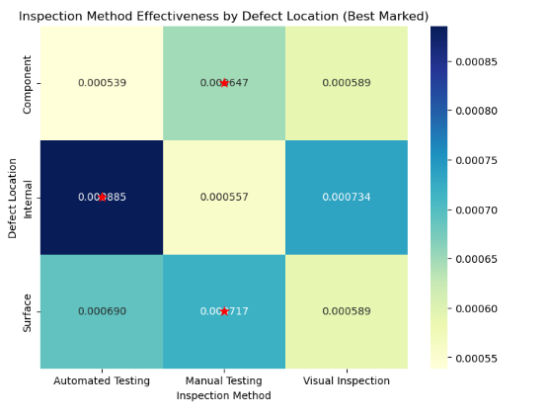
Analysis
The linear regression model’s RMSE of 294 indicates that while the model captured some underlying patterns, repair costs are influenced by more complex, non-linear relationships. The random forest model demonstrated moderate overall accuracy but struggled with predicting critical defects. Its stronger performance with non-critical defects suggests that additional data or rebalancing techniques may be necessary to improve sensitivity to critical cases.
The prescriptive analysis reinforced the importance of selecting inspection methods based on defect location. Automated testing proved most effective for internal defects, while manual testing was more reliable for surface and component defects. Visual inspection was consistently the least effective method.
Conclusion
The random forest model is the most reliable approach for predicting defect severity. Manual testing remains effective for surface and component defects, while automated testing is best suited for internal defects. Predicting repair costs requires more advanced modeling to minimize errors.
Assumptions
This analysis assumes that inspection methods are applied consistently across defect types and locations. It also assumes that the simulated Kaggle dataset reasonably reflects real-world defect patterns.
Limitations
The dataset showed a significant imbalance between critical and non-critical defects, negatively affecting model performance. Linear models also struggled to capture the non-linear relationships present in repair cost data.
Challenges
The small sample size and the need to encode categorical variables posed challenges during model development. Additionally, because the dataset is simulated, it may not fully represent the complexities of real-world manufacturing environments.
Future Uses/Additional Applications
Future work could include forecasting defect frequency to prevent production disruptions, optimizing inspection scheduling, integrating real-time defect detection through sensors, and improving repair cost prediction using more advanced machine learning models.
Recommendations
Organizations should adopt the random forest model for severity classification and align inspection methods with defect locations by using manual testing for surface and component defects and automated testing for internal defects. Visual inspection should be used sparingly due to its lower effectiveness. Collecting more balanced data on critical defects will also help improve model accuracy.
Implementation Plan
The implementation plan includes deploying the random forest model for severity classification and training quality control employees to interpret model outputs. Organizations should adopt prescriptive recommendations by assigning manual testing to surface and component defects and automated testing to internal defects. Ongoing monitoring of defect detection and repair costs will help validate the model’s recommendations. Quarterly model evaluations and continuous data collection will ensure that the model remains accurate as new trends emerge.
Ethical Assessment
Ethical considerations include avoiding the use of defect data to assign blame to workers, ensuring that product identifiers cannot be traced back to customers or employees, maintaining fairness in defect classification, and promoting transparency in how model decisions are made.

References
Cayabyab, G. (2025, March 13). Understanding Manufacturing Defects.
A Comprehensive Guide to Manufacturing Defects | SafetyCulture
Quality Gurus. (2025). Quality Control: Understanding Its Importance, Benefits, Approaches and Key Strategies.
https://www.qualitygurus.com/quality-control-101-understanding-its-importance-benefits-approaches-and-key-strategies/
HQTS. (2024, September 13). Explaining the 3 types of quality defects in manufacturing (AQL classification).
https://www.hqts.com/aql-quality-defects/

10 Questions
  - What are the most common defect types?
    - All defect types occur at similar frequencies, with no single type dominating. Cosmetic defects appear slightly more often, but overall distribution is balanced.
  - Which inspection methods detect each severity level most effectively?
    - Manual inspection detects the most Minor defects.
    - Automated inspection is strongest at detecting Critical and Internal defects.
    - Visual inspection is the least effective across all severity levels.
  - How does inspection effectiveness vary by defect location?
    - Manual is most effective for Surface and Component defects.
    - Automated is most effective for Internal defects.
    - Visual underperforms for all locations.
  - Are certain defect types more likely to be critical?
    - Internal structural defects show a higher likelihood of being Critical, while cosmetic and surface-level defects tend to be Minor or Moderate.
  - Which defect types are most costly?
    - Cosmetic defects show slightly higher average repair costs.
  - Does severity impact repair costs?
    - Higher severity levels are associated with higher repair costs, although the relationship is not perfectly linear.
  - Are there seasonal trends in defect occurrence?
    - January shows the highest defect count and June the lowest.
  - Do certain defect locations show higher defect rates?
    - Surface and Component defects appear slightly more frequently than Internal defects.
  - Does inspection method influence severity detected?
    - The inspection method strongly affects which severity levels are found.
      - Manual → more Minor defects
      - Automated → more Critical defects
      - Visual → lowest detection across all severities
  - How accurately can repair costs be predicted?
    - Linear Regression performed poorly (RMSE ≈ 294), indicating non-linear patterns.
    - Overall, repair cost prediction is moderately accurate, but could improve with more features.

Appendix 1
This appendix contains screenshots from the complete Python code used for data preparation, exploratory analysis, predictive modeling, and prescriptive analytics. The Jupyter Notebook file includes all preprocessing steps, visualizations, model training procedures, evaluation metrics, and supporting calculations referenced throughout the white paper.
